Tab 1
Results:
- question: I see that for mu but is that true for beta?
  - The beta band story is actually more nuanced than previously described. In the C3 plots, high performers are consistently above low performers across beta for left hand right hand and feet. But for tongue at C3, the curbes are much closer together and actually cross in the beta range around 20-25 Hz. At C4, the separation is less consistent, for right hand and feet the curves are close, and for tongue C4 the low performers actally appear slightly higher in parts of the beta range. So the beta finding is real but weaker and less consistent than the mu finding. The mu peak difference around 8-12 Hz is the cleaner and more defensible observation.
- question: should other channels be explored aside c3 and c4?
  - Yes other channels should be explored. C3 and C4 are the standard motor cortex channels for hand iamgery, but your dataset has 22 channels and the tasks include feet and and tongue which activate different cortical areas. For feet imagery, the relevant channels are closer to midline Cz and CPz because foot motor cortex is in the medial wall. For tongue, the representation is more lateral and inferior. Beyond task-specific channels, the topographic map you got is interesting precisely because it showed unexpected left-hemisphere differences, which suggests looking at FC3 and FC1 (frontal-central index 1 and 3 in the channel layout) might reveal frontal theta differnces that predict BCI performance, consistent with the Ahn & Jun 2013 paper.
- question: are any of these findings novel?
  - The general finding that low BCI performers have weaker mu/beta power is not new. What is more interesting is the spatial redistribution in the topographic difference map, the left hemisphere excess power in low performers relative to high performers. BUT STILL SUBTLE
- question: what are the next steps then? should I do ERD? feature analysis?
- First define PSD and topographic maps. These plots show the raw EEG signals directly, completely independent of any model. These results were found plotting mean PSD without subtracting a rest baseline, so absolute power rather than ERD
- PSD plot results: High performers have consistently higher overall power than low performers across virtually all frequencies and all four tasks (question: I see that for mu but is that true for beta?). This is counterintuitive at first, woul expect good BCI subjects to show lower power during motor imagery (ERD effect). But what we're seeing is a signal quality difference, not an ERD difference. High performers have stronger, cleaner EEG signals overall. Their brain activitiy is more detectable. The fact that this pattern holds across all four classes (left hand, right hand, feet, tongue) and both channels (C3 and C4) (question: should other channels be explored?) suggests this is a subject-level signal quality difference, not a task-specific effect. Low performers have weaker signals everywhere not just one class.
- Topographic map results: (question: are any of these findings novel?). The left side (around C3/left motor cortex) is strongly blue meaning low performers actually have more power than high performers over the left hemisphere. The posterior and right temporal regions are strongly red meaning high performers have more power in those areas. This suggests the difference between groups isn't simply 'high performers have stronger signals everywhere', there's a spatial redistribution. (question: what are the next steps then? should I do ERD? feature analysis?). High performers show relatively more power in posterior and right hemispheric regions while low performers show relatively more left-hemispheric power. This could reflect different neural strategies or cortical organization between the groups.
- Takeaways: PSD confirms that low performers have weaker motor cortex signals overall, which provides a neurophysiological basis for why classifiers struggle with them (there's simply less signal to detect). Second, the topographic difference suggests the groups differ not just in signal strength but in spatial distribution of activity, which may explain why simple amplitude-based augmentation (Gaussian noise) didn't help low performers it adds noise uniformly without addressing the underlying spatial reorganization

- High performers show -4.9% for Mu ERD%, which is a small but genuine desynchronization (power decreases during motor imagery relative to rest, which is the expected ERD response). Low performers show +18.6%, power actually increases motor imagery which is the opposite of the expected response. This is called Event-Related Synchronization (ERS) rather than ERD, and it means low performers' brains are not producing the sensorimotor rhythm suprpression that BCIs rely on to detect motor intent. Their mu rhythm doesn't know to "quiet down" during motor imagery.

- Beta band: high performers show -6.2%, a clear meaningful desynchronization in the beta range, which is what we'd expect. The beta ERD is actually stronger than the mu ERD for high performers which makes sense since beta is the dominant motor rhythm during sustained imagery. Low performers show -0.3% essentially flat no meaningful beta desynchronization at all

- The pattern is unambiguous: high performers produce genuine ERD in both mu and beta bands, while low performers produce either no desynchronization or active synchronization. This explains why classifiers struggle with low performers, there is simply no reliable ERD signature for the model to detect. The signal that FBCSP, EEGNet, and ATCNet are all trying to find is present in high perfromers and absent in low performers. THIS ALSO GIVES A MORE PRECISE FRAMING FOR WHY SSL PRETRAINING MIGHT HELP LOW PERFORMERS SPECIFICALLY: if the model has learned general EEG representations from unlabeled data, it may be able to detect subtler or differently organized neural patterns in subjects who don't produce canonical ERD.

- ERD topomap:
- High performers (left panel, mostly blue): The entire scalp shows negative ERD% (blue = desynchronization), with the strongest desynchronization concentrated over the central and central-posterior regions, exactly where C3, C4, Cz, and the surrounding motor cortex electrodes sit. This is textbook motor imagery ERD. The brain is supressing mu/beta oscillations specifically over the sensorimotor cortex during motor imagery, which is precisely the signal that classifiers are trained to detect. The small red patch at the bottom is occipital/parietal and isn't motor-relevant

- Low performers (middle panel, mostly red):
- Pattern is inverted so instead of desynchronization low performers show widespread synchronization (positive ERD%, red) across most of the scalp with the strongest synchronization in the central and frontal regions. The only midly negative region is on the right lateral edge. This means low performers' sensorimotor cortex is not supressing mu/beta activity during motor imagery, the oscillations either stay the same or increase. There is no ERD signal for classifiers to find.

- Difference panel (right all blue): the differnce map is unifromly blue meaning high performers have more negative ERD% everywhere compared to low performers. The deepest blue is over the central motor cortex region, confirming the differnce is strongest exactly where motor imagery signals should originate.

- The reason FBCSP, EEGNet, and ATCNet all struggle with low performers is because there is no motor cortex ERD for the model to detect. High performers produce a clean, spatially focused desynchronization. Low performers produce the opposite.

- Motivation for SSL: low performers do not produce canonical ERD patterns during motor imagery. SSL pretraining on unlabeled EEG may enable models to learn alternative neural represntations beyond ERD that could capture whatever signal low performers do produce, rather than relying exclusively on the ERD signature that is absent in this group

Tab 2
Instead of training your model from scratch on 288 trials per subject, first "warm up" the model on a different EEG dataset or task to learn general EEG representations then fine tune on BCI IV-2a. This is actually a well-established concept in EEG called cross-subject or cross-dataset transfer learning and it's been studied extensively.

3 options:
Option 1: warm up on a different EEG dataset
Option 2: warm up on a simpler proxy task first
Option 3: warm up using self-supervised learning on unlabeled EEG**. (pretrain on all 9 subjects' raw EEG without labels using a reconstruction or contrastive objective, then fine-tune with labels. This is closest in spirit to what the paper does, the warmup phase has no task-specific supervision it just learns structure). Contrastive SSL idea we discussed earlier, still the most theoretically motivated but also the most complex to implement

SimCLR and contrastive SSL on EEG motor imagery has been done. Cross-subject SSL on BCI IV-2a has been done. What has NOT been done in this specific framing is: does SSL pretraining disproportionately help BCI-inefficient subjects in within-subject classification?

- The key design decision is: what do you pretrain on? You have two options.
- Option A — Leave-one-subject-out SSL pretraining. For each target subject, pretrain the encoder on the other 8 subjects' unlabeled data, then fine-tune on the target subject's 288 labeled trials. This tests whether representations learned from other subjects' EEG generalize to the target subject — especially relevant for low performers who may benefit from seeing more diverse EEG patterns.
- Option B — Within-subject SSL warmup. For each subject, pretrain the encoder on that subject's own unlabeled data (you can use both session 1 and session 2 data without labels), then fine-tune on session 1 labels. This is closer to the "warm up before you train" idea from your paper — the model learns the subject's own EEG structure before seeing any class labels.
- Option A is more novel and more directly relevant to BCI illiteracy because it tests whether cross-subject pretraining specifically helps low performers. Option B is simpler to implement. I recommend Option A.

SSL-BYOL mean 0.6875 vs FBCSP mean 0.634 is a +0.053 improvement across all subjects just from pretraining on other subjects' unlabeled data. That's comparable to EEGNet without augmentation (0.713) and well above FBCSP

The mean change in accuracy is identical for both high and low performers (+0.053), BYOL pretraining helps both groups equally on average. But interesting results for the variance within the low performer group. Subject 6 gets the single largest gain of any sibject and subject 5 does 3rd best. These are the 2 hardest subjects, the ones who showed essentially 0 ERD in the topographic map. When canonical ERD is absent, cross-subject pretraining provides representations that can detect whatever alternative neural patterns those subjects do produce. Subject 4 going slightly negative is one inconsistency

SSL + SSR augmentation mean of 0.7346 is the best result across all models and conditions. SSL + aug beats every non-augmented model and is competitive with EEGNet+aug despite using a fundamentally different training paradigm. Low performers gain +.103 on average vs high performers +0.098 essentially equal. But looking at subjects 5 and 6 specifically these are the 2 hardest subjects the ones with essentially zero ERD in the topomap. Subject 5 gains +.177 and subject 6 gains +.152 which are the two largest gains among low performers/overall. Subject 2 is the outlier +0.003 but it has always been the most resistant subject across all models

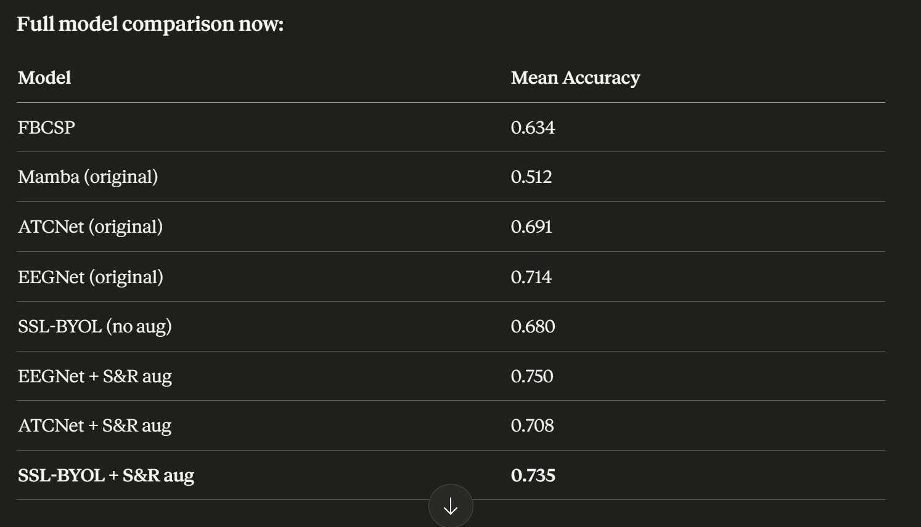

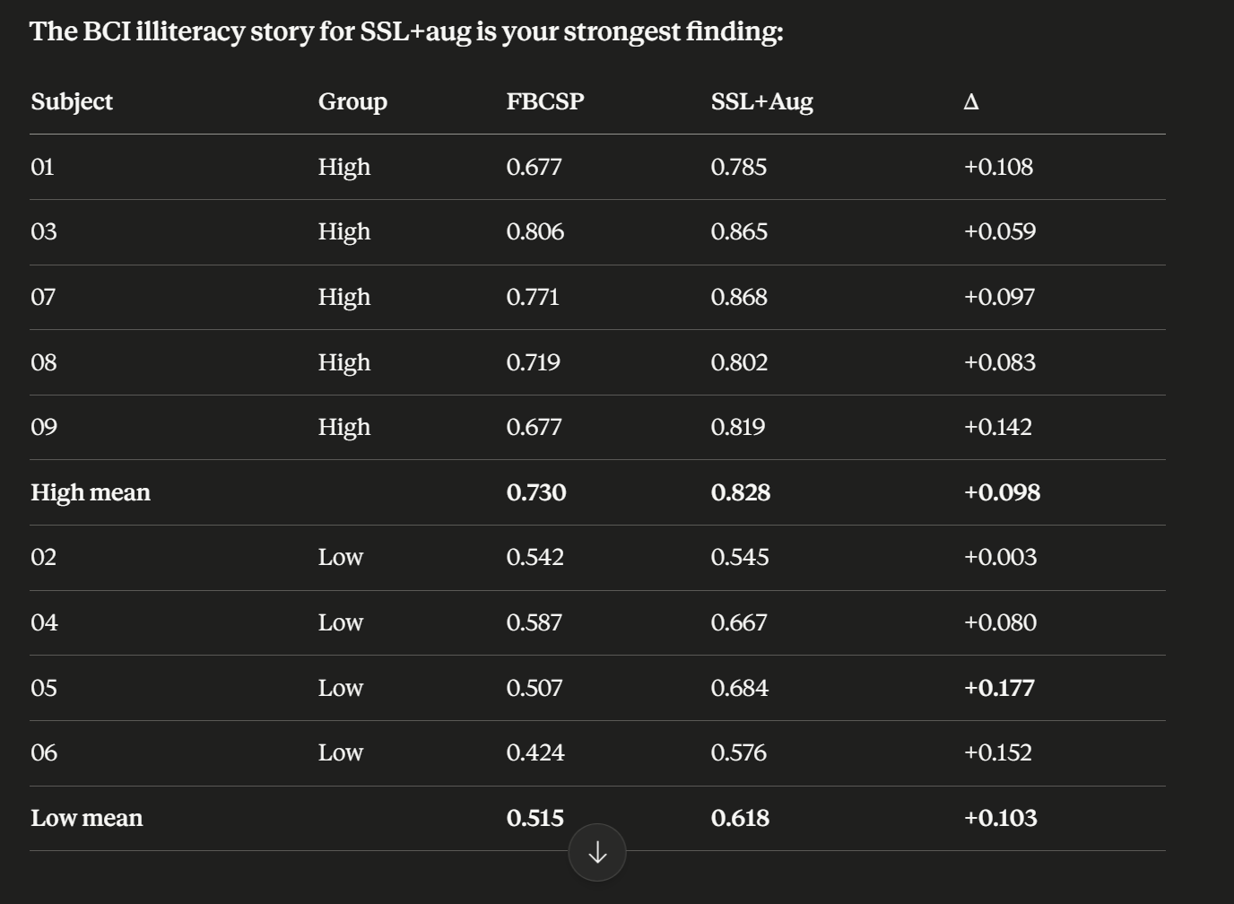
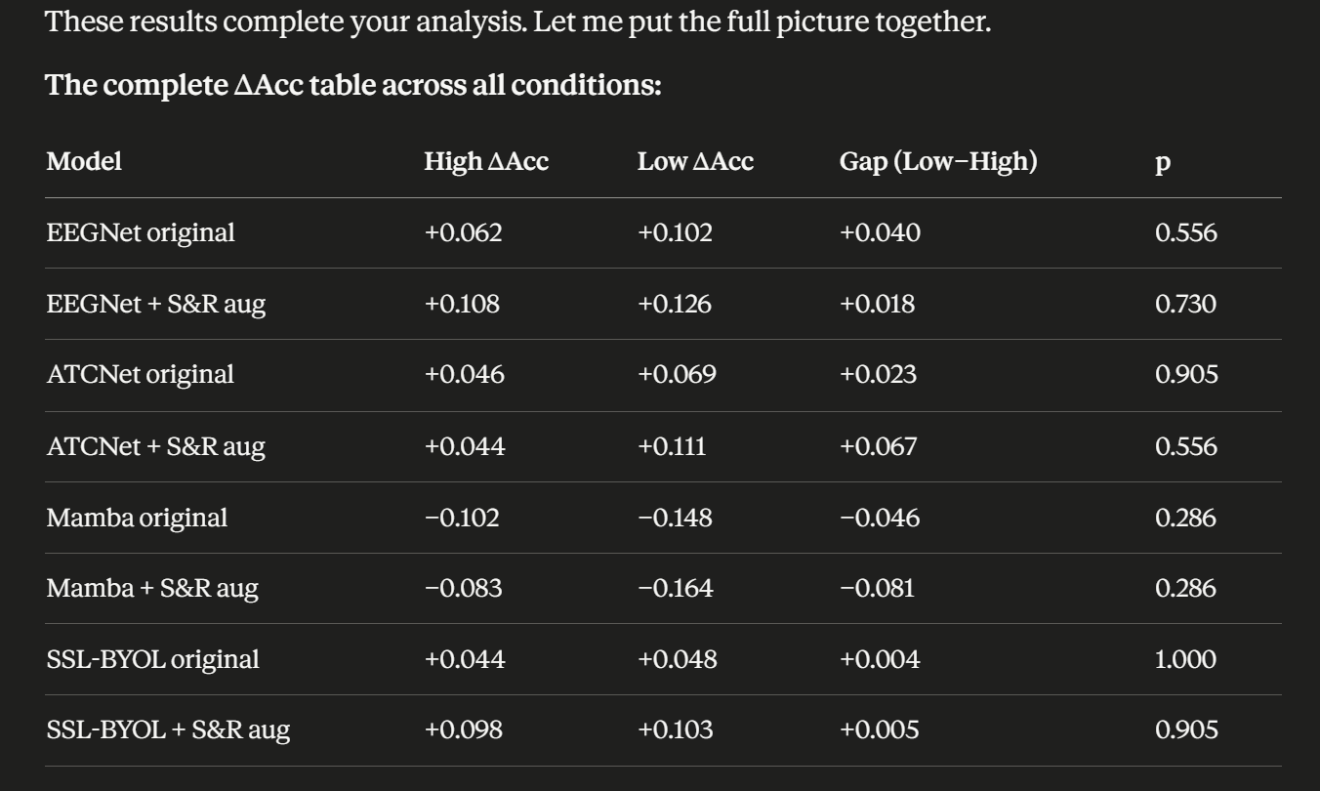

Most consistent finding across entire experiment is that S&R augmentation reliably amplifies the low-performer advantage. Every model except Mambas shows a larger low-high gap with augmentation than without. ATCNet shows the strongest differential effect. SSL-BYOL shows the most consistent absolute gains for both groups when combined with agumentation

SSL-BYOL's finding is partcularly interesting: the gap between high and low performers is nearly identical, meaning BYOL pretraining helps both groups almost equally. This is actually a positive equity finding, it doesn't disproportionately favor already good subjects the way some augmentation strategies do. Combined with S&R augmentation it produces the best overall mean accuracy while maintaining roughly equal benefit across groups

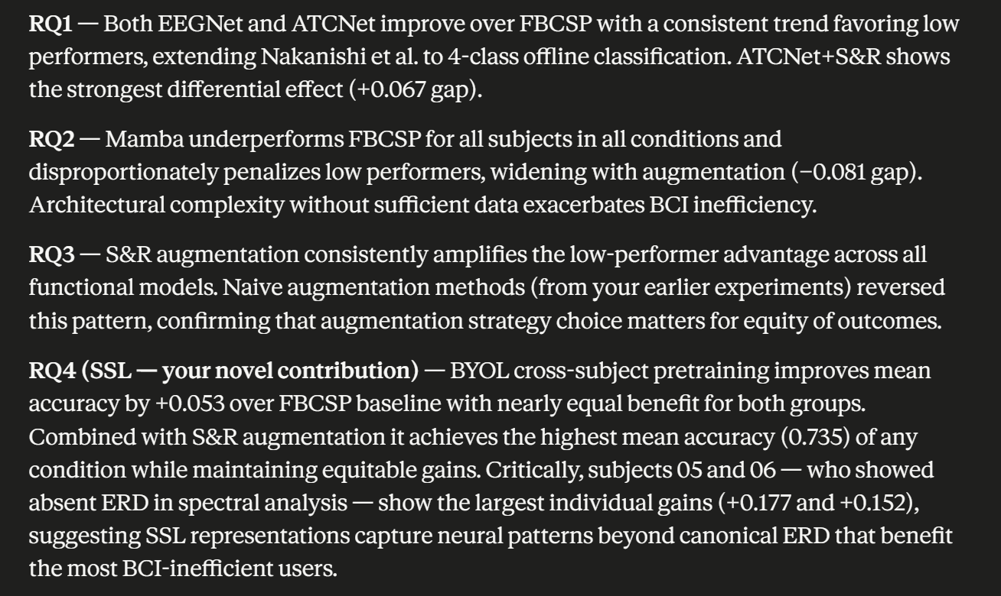

-ATCNet succeeds because it combines a convolutional block that explicitly models spatial filtering across electrodes (analogous to CSP inFBCSP) a multi-head self-attention module for global temporal context, and a TCN block for sequential dependencies all with inductive biases specifically designed for fixed-length EEG trials. Mamba's selective state space mechanism was designed for very long sequences (thousands of tokens) in NLP where its linear complexity advantage over attention is meaningful. On a 512-sample EEG trial this advantage is irrelevant, and the SSM's parameters (approximately 3*expand*d_model^2 per block) represent overcapacity relative to the 288 training trials available. The debug loss curve confirmed this: MI-Mamba reached near-zero training loss by epoch 100, indicating complete memorization of training data rather than learning genralizable representations.

Tab 3
=== Subject 01 ===
BYOL pretraining on 2304 trials (excluding subject 01)
Epoch 0: loss=-0.4327
Epoch 50: loss=-0.8520
Epoch 100: loss=-0.8647
Epoch 150: loss=-0.8799
Epoch 200: loss=-0.8894
Epoch 250: loss=-0.8863
Subject 01 SSL-BYOL: 0.7778 (FBCSP: 0.677 Δ: +0.101)

=== Subject 02 ===
BYOL pretraining on 2304 trials (excluding subject 02)
Epoch 0: loss=-0.4606
Epoch 50: loss=-0.8320
Epoch 100: loss=-0.8467
Epoch 150: loss=-0.8610
Epoch 200: loss=-0.8697
Epoch 250: loss=-0.8768
Subject 02 SSL-BYOL: 0.5486 (FBCSP: 0.542 Δ: +0.007)

=== Subject 03 ===
BYOL pretraining on 2304 trials (excluding subject 03)
Epoch 0: loss=-0.4201
Epoch 50: loss=-0.8422
Epoch 100: loss=-0.8601
Epoch 150: loss=-0.8818
Epoch 200: loss=-0.8907
Epoch 250: loss=-0.9050
Subject 03 SSL-BYOL: 0.8507 (FBCSP: 0.806 Δ: +0.045)

=== Subject 04 ===
BYOL pretraining on 2304 trials (excluding subject 04)
Epoch 0: loss=-0.4439
Epoch 50: loss=-0.8562
Epoch 100: loss=-0.8718
Epoch 150: loss=-0.8868
Epoch 200: loss=-0.8921
Epoch 250: loss=-0.8983
Subject 04 SSL-BYOL: 0.5694 (FBCSP: 0.587 Δ: -0.018)

=== Subject 05 ===
BYOL pretraining on 2304 trials (excluding subject 05)
Epoch 0: loss=-0.4474
Epoch 50: loss=-0.8454
Epoch 100: loss=-0.8623
Epoch 150: loss=-0.8721
Epoch 200: loss=-0.8843
Epoch 250: loss=-0.8921
Subject 05 SSL-BYOL: 0.5868 (FBCSP: 0.507 Δ: +0.080)

=== Subject 06 ===
BYOL pretraining on 2304 trials (excluding subject 06)
Epoch 0: loss=-0.4499
Epoch 50: loss=-0.8567
Epoch 100: loss=-0.8710
Epoch 150: loss=-0.8851
Epoch 200: loss=-0.8883
Epoch 250: loss=-0.8918
Subject 06 SSL-BYOL: 0.5660 (FBCSP: 0.424 Δ: +0.142)

=== Subject 07 ===
BYOL pretraining on 2304 trials (excluding subject 07)
Epoch 0: loss=-0.3866
Epoch 50: loss=-0.8387
Epoch 100: loss=-0.8600
Epoch 150: loss=-0.8785
Epoch 200: loss=-0.8939
Epoch 250: loss=-0.9041
Subject 07 SSL-BYOL: 0.7951 (FBCSP: 0.771 Δ: +0.024)

=== Subject 08 ===
BYOL pretraining on 2304 trials (excluding subject 08)
Epoch 0: loss=-0.4194
Epoch 50: loss=-0.8475
Epoch 100: loss=-0.8649
Epoch 150: loss=-0.8752
Epoch 200: loss=-0.8903
Epoch 250: loss=-0.9018
Subject 08 SSL-BYOL: 0.7882 (FBCSP: 0.719 Δ: +0.069)

=== Subject 09 ===
BYOL pretraining on 2304 trials (excluding subject 09)
Epoch 0: loss=-0.4498
Epoch 50: loss=-0.8381
Epoch 100: loss=-0.8621
Epoch 150: loss=-0.8790
Epoch 200: loss=-0.8872
Epoch 250: loss=-0.8910
Subject 09 SSL-BYOL: 0.7049 (FBCSP: 0.677 Δ: +0.028)

SSL-BYOL Mean: 0.6875
FBCSP Mean: 0.6344

Tab 4
=== Subject 01 ===
BYOL pretraining on 2304 trials (excluding subject 01)

/usr/local/lib/python3.12/dist-packages/torch/nn/modules/conv.py:548: UserWarning: Using padding='same' with even kernel lengths and odd dilation may require a zero-padded copy of the input be created (Triggered internally at /pytorch/aten/src/ATen/native/Convolution.cpp:1025.)
return F.conv2d(

Epoch 0: loss=-0.4446
Epoch 50: loss=-0.8475
Epoch 100: loss=-0.8626
Epoch 150: loss=-0.8808
Epoch 200: loss=-0.8913
Epoch 250: loss=-0.9069
Subject 01: SSL 0.7812 | SSL+Aug 0.7847 | FBCSP 0.677 | Δ SSL: +0.104 | Δ SSL+Aug: +0.108

=== Subject 02 ===
BYOL pretraining on 2304 trials (excluding subject 02)
Epoch 0: loss=-0.4217
Epoch 50: loss=-0.8484
Epoch 100: loss=-0.8760
Epoch 150: loss=-0.8953
Epoch 200: loss=-0.9031
Epoch 250: loss=-0.9124
Subject 02: SSL 0.5278 | SSL+Aug 0.5451 | FBCSP 0.542 | Δ SSL: -0.014 | Δ SSL+Aug: +0.003

=== Subject 03 ===
BYOL pretraining on 2304 trials (excluding subject 03)
Epoch 0: loss=-0.4364
Epoch 50: loss=-0.8584
Epoch 100: loss=-0.8804
Epoch 150: loss=-0.8968
Epoch 200: loss=-0.9089
Epoch 250: loss=-0.9122
Subject 03: SSL 0.8750 | SSL+Aug 0.8646 | FBCSP 0.806 | Δ SSL: +0.069 | Δ SSL+Aug: +0.059

=== Subject 04 ===
BYOL pretraining on 2304 trials (excluding subject 04)
Epoch 0: loss=-0.4413
Epoch 50: loss=-0.8417
Epoch 100: loss=-0.8523
Epoch 150: loss=-0.8717
Epoch 200: loss=-0.8793
Epoch 250: loss=-0.8911
Subject 04: SSL 0.5903 | SSL+Aug 0.6667 | FBCSP 0.587 | Δ SSL: +0.003 | Δ SSL+Aug: +0.080

=== Subject 05 ===
BYOL pretraining on 2304 trials (excluding subject 05)
Epoch 0: loss=-0.4388
Epoch 50: loss=-0.8494
Epoch 100: loss=-0.8774
Epoch 150: loss=-0.9029
Epoch 200: loss=-0.9165
Epoch 250: loss=-0.9241
Subject 05: SSL 0.5799 | SSL+Aug 0.6840 | FBCSP 0.507 | Δ SSL: +0.073 | Δ SSL+Aug: +0.177

=== Subject 06 ===
BYOL pretraining on 2304 trials (excluding subject 06)
Epoch 0: loss=-0.4382
Epoch 50: loss=-0.8536
Epoch 100: loss=-0.8884
Epoch 150: loss=-0.8987
Epoch 200: loss=-0.9009
Epoch 250: loss=-0.9044
Subject 06: SSL 0.5521 | SSL+Aug 0.5764 | FBCSP 0.424 | Δ SSL: +0.128 | Δ SSL+Aug: +0.152

=== Subject 07 ===
BYOL pretraining on 2304 trials (excluding subject 07)
Epoch 0: loss=-0.4235
Epoch 50: loss=-0.8439
Epoch 100: loss=-0.8528
Epoch 150: loss=-0.8700
Epoch 200: loss=-0.8744
Epoch 250: loss=-0.8791
Subject 07: SSL 0.7188 | SSL+Aug 0.8681 | FBCSP 0.771 | Δ SSL: -0.052 | Δ SSL+Aug: +0.097

=== Subject 08 ===
BYOL pretraining on 2304 trials (excluding subject 08)
Epoch 0: loss=-0.4093
Epoch 50: loss=-0.8436
Epoch 100: loss=-0.8557
Epoch 150: loss=-0.8719
Epoch 200: loss=-0.8852
Epoch 250: loss=-0.8963
Subject 08: SSL 0.7986 | SSL+Aug 0.8021 | FBCSP 0.719 | Δ SSL: +0.080 | Δ SSL+Aug: +0.083

=== Subject 09 ===
BYOL pretraining on 2304 trials (excluding subject 09)
Epoch 0: loss=-0.4410
Epoch 50: loss=-0.8645
Epoch 100: loss=-0.8906
Epoch 150: loss=-0.9042
Epoch 200: loss=-0.9107
Epoch 250: loss=-0.9138
Subject 09: SSL 0.6979 | SSL+Aug 0.8194 | FBCSP 0.677 | Δ SSL: +0.021 | Δ SSL+Aug: +0.142

Means:
SSL (no aug): 0.6802
SSL + S&R aug: 0.7346
FBCSP: 0.6344

Meeting Notes
- Notes for meeting:
- -changed from the old augmentation to Segmentation and Recombination based on the 3 papers we had looked at last time. question: did any of the papers say this?
  - -S&R was chosen from the Roy et al paper which compared S&R against Gaussian noise, sliding window, etc and significantly outperformed all of them
- -the technique takes 288 trials per subject and generates 2 synthetic copies per original trial to get 864 training trials per subject
- -this means every augmented trial comes from a real EEG recording of the same class
- -return (864, 22, 512) from original (288, 22, 512)
- -after running S&R augmentation on EEGNet, Mamba, and ATCNet, EEGNet performed slightly better per subject, ATCNet kinda did, and Mamba had no effect (question is that right)
  - EEGNet improved meaningfully, ATCNet improved modestly/kinda did and mamba had essentially no effect.
- -found though that S&R augmentation consistently preserved and strengthened the low performer advantage for EEGNet and ATCNet (question: what shows this the p-value or gap?). ATCNet +S&R showed the strongest differential effect
  - The gap is what shows it. A positive gap means low performers gained more than high performers relative to FBCSP. The models that were consistent with hyptohesis:
  - -EEGNet original, EEGNet augmented, ATCNet original, ATCNet augmented
- -question: is the spectral analysis novel at all or what is novel about it
  - What is more interesting is the ERD topomap showing the specific spatial pattern, that low performers dont just have weaker ERD but actually show active synchronization across the motor cortex while high performers show clean bilateral desynchronization (novel to say these subjects have absent ERD and they benefit most from cross subject SSL pretraining)
- -found that low performers do not produce canonical ERD during motor imagery. Their sensorimotor cortex doesn't suppress mu/beta oscillatons when imagining movement so there is no signal for classifiers to detect
- -wanted to try "warming up a model" technique and also apply contrastive learning specifically looking at high low performer difference. so did SSL BYOL (question what is that and has it been done before or is this novel)
- -question for the EEG augmentations used during pretraining why did we do gausian noise and random temporal masking? esp gaussian noise because I thought that made things worse?
  - we are able to apply gaussian noise for BYOL pretraining because the noise isnt applied to labeled training data its applied to unlabeled pretraining data from other subjects to create 2 different views of the same trial
- -The Design: leave one subject out pretraining so for each target subject we pretrain the BYOL encoder on the other 8 subjects' unlabeled data. Then fine-tune on the subjects 288 labled trials in order to test whether cross subject EEG representations help within-subject classification. Reached about 90% cosine agreeent between online and target representations
- -Results showed that both groups benefit almost identically from SSL pretraining mean gains are +0.053 no aug and +0.098/+.103 with aug. However subjects 5 and 6 the 2 subjects with absent ERD in the topographic map show the largest individual gains of any subjects in the entire experiment
- -next steps: want to run BYOL ablation study for each of the 4 low performing subjects, am re-running BYOL pretraining 8 times each time removing one of the other subjects from the pretraining set. The accuracy drop when each subject is removed tells you how much that subject contributed to the useful pretraining signal

Draft Outline
- a title: Do Modern Deep Learning Architectures Disproportionately Benefit BCI-Inefficient Users? An Empirical Analysis on Motor Imagery EEG Classification
- Authors: Chris Dollo and Madeline Rippin
- a brief (at most 200 word) abstract:
  - Brain-computer interfaces (BCIs) based on motor imagery electroencephalography (EEG) offer transformative potential for assistive technologies, yet an estimated 15–30% of users cannot effectively operate them, a phenomenon termed BCI inefficiency. Prior work has shown that convolutional neural networks improve classification for inefficient users relative to traditional signal processing in binary tasks, but this has not been extended to multi-class settings or newer architectures. We extend this investigation to 4-class motor imagery using BCI Competition IV Dataset 2a, comparing five approaches: Filter Bank Common Spatial Pattern (FBCSP), EEGNet, ATCNet, a Mamba-based selective state space model, and a Bootstrap Your Own Latent (BYOL) self-supervised approach with leave-one-subject-out cross-subject pretraining. High and low performer groups are defined via median split on FBCSP kappa, and we analyze whether gains over the baseline are disproportionately larger for low performers, with and without Segmentation and Recombination augmentation. Spectral analysis confirms that low performers exhibit absent mu/beta event-related desynchronization over motor cortex, providing neurophysiological grounding for their classification difficulty. EEGNet and ATCNet consistently trend toward favoring low performers, while Mamba underperforms FBCSP for all subjects. SSL-BYOL achieves the strongest overall performance with the largest individual gains for subjects with most absent ERD. These results constitute the first systematic analysis of BCI inefficiency across this model hierarchy in 4-class classification and the first investigation of whether cross-subject SSL pretraining disproportionately benefits BCI-inefficient users.
- a description and motivation of the problem:
  - Brain-computer interfaces based on motor imagery EEG have emerged as a promising technology for individuals with severe motor disabilities, enabling direct communication between the brain and external devices such as prosthetic limbs, wheelchairs, and augmentative communication systems without requiring any physical movement. The core signal underlying most motor imagery BCIs is event-related desynchronization (ERD), a reduction in mu (8–12 Hz) and beta (13–30 Hz) oscillatory power over the sensorimotor cortex that occurs when a user imagines performing a movement. Classifiers trained to detect these patterns can decode motor intent with sufficient accuracy for practical control in favorable conditions.
  - A persistent and clinically significant obstacle is BCI inefficiency: an estimated 15–30% of users are unable to produce ERD patterns robustly enough for a classifier to exceed 70% accuracy, even after extensive training \cite{blankertz2009bci, ahn2013theta}. This is not merely an accuracy problem, it is an equity problem. The patients who most urgently need BCI technology, including individuals with ALS, stroke survivors, and upper-limb amputees, are often precisely those who are harder to classify, whether due to neurological disruption, limited motor cortex plasticity, or natural inter-individual variability in sensorimotor rhythm generation \cite{blankertz2009bci}. Critically, \citet{ahn2013theta} demonstrated that high resting-state theta and low alpha power may predict poor BCI performance, suggesting that BCI inefficiency has identifiable neurophysiological correlates rather than being purely random variability.
  - Recent deep learning models have dramatically improved mean accuracy on benchmark datasets such as BCI Competition IV Dataset 2a \cite{tangermann2012review}, but nearly all published work reports average accuracy across subjects without examining whether these gains are distributed equitably across the performance spectrum. \citet{nakanishi2022classification} provided the first direct evidence that CNNs disproportionately benefit inefficient users in a 2-class online BCI paradigm, with improvements of up to 28% for the lowest performers relative to a CSP+LDA baseline. However, that work was limited to binary classification with online accuracy scores, leaving open whether the finding extends to the more clinically relevant 4-class setting, to offline evaluation protocols, and to more recent architectures beyond CNNs. Whether modern deep learning approaches, including temporal convolutional networks, state space models, and self-supervised pretraining, specifically help the users who need BCIs most remains an open and practically important question. Answering it has direct implications for model selection in clinical deployment, where the goal is not maximizing mean accuracy across a population but ensuring equitable performance for the full range of potential users.
- a description of the questions you are addressing
  - This work addresses four research questions spanning both the architectural and data dimensions of BCI inefficiency.
  - RQ1: Does EEGNet improve classification accuracy for BCI-inefficient subjects more than BCI-efficient subjects, relative to the FBCSP baseline? Prior work by \citet{nakanishi2022classification} demonstrated this effect for 2-class online motor imagery, but it has not been tested in 4-class offline classification. We hypothesize that EEGNet's ability to learn spatial filters directly from raw EEG, rather than relying on hand-crafted filter bank decompositions, allows it to detect weaker or less canonical ERD patterns that FBCSP cannot capture, disproportionately benefiting subjects whose sensorimotor rhythms are atypical.
  - RQ2: Does ATCNet further amplify this effect relative to EEGNet, and does a Mamba-based state space model provide additional benefit? ATCNet combines convolutional spatial filtering with multi-head self-attention and a temporal convolutional network, giving it both local and global temporal modeling capacity. We hypothesize this richer architecture may better characterize the diffuse or temporally irregular ERD patterns observed in low performers. Mamba \cite{gu2023mamba} offers an alternative through its selective state space mechanism, which adaptively retains or discards information along the sequence, a property that could in principle capture weak signal in noisy trials. However, given Mamba's larger parameter count relative to EEGNet and ATCNet, we also consider the possibility that it overfits on the 288 available training trials, particularly for subjects whose signals are weakest.
  - RQ3: Does Segmentation and Recombination (S&R) data augmentation \cite{lotte2015} differentially benefit low-performing subjects? S&R generates synthetic trials by recombining segments from same-class trials, expanding the training set from 288 to 864 trials per subject without introducing artificial signal artifacts. We ask whether this additional training data closes the performance gap between high and low performers, or whether it provides uniform benefit across groups, and whether the answer differs across model architectures.
  - RQ4: Does cross-subject BYOL self-supervised pretraining \cite{grill2020byol} disproportionately benefit BCI-inefficient subjects? We implement a leave-one-subject-out pretraining design in which the BYOL encoder is trained on unlabeled EEG from the other eight subjects before fine-tuning on the target subject's labeled data. This design is motivated directly by the spectral analysis finding that low performers exhibit absent mu/beta ERD: if canonical ERD is not present in a subject's training data, a model pretrained on diverse EEG representations from other subjects may learn to detect alternative neural patterns that supervised training on 288 trials alone cannot discover. This constitutes the first investigation of whether SSL pretraining disproportionately benefits BCI-inefficient users.
  - Together these four questions address the architectural dimension (which model family best serves hard subjects?), the data dimension (does augmentation help hard subjects more?), and the representation learning dimension (does pretraining on cross-subject data unlock patterns that supervised learning misses for inefficient users?). The unifying thread is equity: not whether a model achieves the highest mean accuracy, but whether its gains are distributed in a way that serves the users who need BCIs most.
- a description of your proposed solution,
- a description (longer than in the progress update) of how your solution fits in with what has been previously done on the problem (or related problems),
- evidence of proper experimental methodology,
- a clear description and analysis of your results,
- an analysis of the limitations of your work,
- a solid, evidence-informed discussion of the ethical components, and
- potential follow-up work, both short- and long-term.

Ablation
Ablation study results:
-subject 2: low performers help more than high performers. This is a mixed story subject 2 benefits from both 1 high performer and 2 low performers suggesting it partially shares the alternative neural signature with other low performers but also benefits from seeing canonical ERD
-subject 4: high performers dominate. The low performers contribute very little (removing them makes essentially no difference or slight improvement). This is the clearest 'learning from experts' pattern subject 4 benefits primarily from seeing canonical ERD patterns from high performing subjects
-subject 5: other low performers are most important. Removing subject 4 causes the largest drop of any subject across the entire ablation and removing subject 2 causes the 2nd largest drop (both are low performers). Removing high performers improves accuracy for subject 5. This is the shared alternative nerual signature story. Given that subject 5 had absent ERD in the topomap, this suggests there is a common neural pattern among BCI inefficient subjects that the BYOL encoder learns and transfers within the low-performer group
-Subject 6: low performers matter most. Subject 4 again is the most important contributor. Subject 6 benefits from both low performer representations and some high performer representations. subject 5 and 6 dont share as much useful signal with each other as either does with subject 4

The cross subject pattern: subject 4 is the most universally useful low performer. Appears as the most important contributor for both subject 5 and 6. This means subject 4's EEG contains reprsentations that transfer to the other hard subjects better than any other subject. Strongly supports the hypothesis that low-performing subjects share a common altenrative nerual signature that BYOL can learn and transfer and subject 4 appears to be the clearest exemplar of that shared pattern

-Claude: The ablation reveals two distinct pretraining patterns among low performers. Subjects 05 and 06 — the two subjects with most absent ERD in the spectral analysis — benefit primarily from pretraining on other low-performing subjects' data, particularly subject 04, suggesting they share a common alternative neural representation that BYOL captures. Subject 04 itself benefits primarily from high-performing subjects (07, 08, 09), suggesting it occupies an intermediate position — too weak for canonical ERD-based classification but close enough to high performers that their representations are informative. Subject 02, the most resistant subject across all models, shows a mixed pattern. This heterogeneity within the low-performer group is itself a novel finding: BCI inefficiency is not a single uniform phenomenon but encompasses at least two subtypes — subjects who share alternative neural patterns with other low performers, and subjects whose pretraining benefit comes primarily from high-performer representations.

Tab 8
These are good notes. Let me go through each one and tell you exactly what to do.

1. Why ATCNet is learning and why Mamba is failing (layers)
Your advisor wants you to look inside the models — understand architecturally why ATCNet succeeds where Mamba fails. This is a legitimate scientific question and the answer will strengthen your discussion section significantly.
For ATCNet — why it works:
ATCNet has three components that give it strong inductive bias for EEG specifically. First, a convolutional block that extracts local spatio-temporal features — similar to EEGNet but with more capacity. Second, a multi-head self-attention module that captures global temporal dependencies across the trial. Third, a temporal convolutional network (TCN) block that models sequential dependencies with dilated causal convolutions. The combination gives ATCNet both local and global temporal modeling while staying compact enough to generalize on 288 trials. The key advantage over Mamba is that ATCNet's attention mechanism is explicitly designed for fixed-length sequences (512 samples), while Mamba's SSM was designed for much longer sequences in NLP where its linear complexity advantage matters. On a 512-sample EEG trial the computational efficiency argument for Mamba disappears, and you're left with a model that has more parameters and less task-specific inductive bias.
For Mamba — why it fails:
The core issue is the parameter count relative to training data. Let me search for the exact parameter counts to give your advisor precise numbers.Good — now I have the exact parameter formula. Let me put together a precise answer for both parts.

Why ATCNet learns and Mamba fails — with specific numbers
The most concrete way to explain this to your advisor is to compute the actual parameter counts for each model. Run this in your notebook:
def count_params(model):
return sum(p.numel() for p in model.parameters() if p.requires_grad)

from braindecode.models import ATCNet
import torch.nn as nn

# Your MI-Mamba
mamba_model = MI_Mamba(n_channels=22, n_classes=4, n_times=512, d_model=32)

# ATCNet wrapper
atcnet = ATCNetWrapper()

# EEGNet
from EEGNet import EEGNetModel
eegnet = EEGNetModel(chans=22, classes=4, time_points=512, temp_kernel=64)

print(f'EEGNet: {count_params(eegnet):,} parameters')
print(f'ATCNet: {count_params(atcnet):,} parameters')
print(f'MI-Mamba: {count_params(mamba_model):,} parameters')
print(f'\nTrials per parameter:')
for name, model in [('EEGNet', eegnet), ('ATCNet', atcnet), ('MI-Mamba', mamba_model)]:
ratio = 288 / count_params(model)
print(f' {name}: {ratio:.6f} trials/param')
The Mamba block uses roughly 3 × expand × d_model² parameters — so with d_model=32 and expand=2 that's approximately 3 × 2 × 32² = 6,144 parameters in the Mamba block alone, plus the spatial conv, BN, and FC layers. The total MI-Mamba parameter count will be in the 10,000–20,000 range.
For context, EEGNet-8,2 has approximately 2,548 parameters — famously compact by design. ATCNet has more parameters than EEGNet but its architecture provides strong EEG-specific inductive bias through its convolutional projection layer, which EEGNet also has but Mamba lacks entirely.
The architectural explanation for your advisor in one paragraph:
ATCNet succeeds because it combines a convolutional block that explicitly models spatial filtering across electrodes (analogous to CSP in FBCSP), a multi-head self-attention module for global temporal context, and a TCN block for sequential dependencies — all with inductive biases specifically designed for fixed-length EEG trials. Mamba's selective state space mechanism was designed for very long sequences (thousands of tokens) in NLP where its linear complexity advantage over attention is meaningful. On a 512-sample EEG trial this advantage is irrelevant, and the SSM's parameters — approximately 3 × expand × d_model² per block — represent overcapacity relative to the 288 training trials available. The debug loss curve confirmed this: MI-Mamba reached near-zero training loss by epoch 100, indicating complete memorization of training data rather than learning generalizable representations.

2. Additional metrics — confusion matrices and regularization
Your advisor is right on both counts. Accuracy alone can be misleading for 4-class problems because it treats all misclassifications equally. A confusion matrix will show whether misclassifications are random or systematic — for example, low performers might systematically confuse left hand with right hand (both are hand imagery with similar spatial ERD patterns) while being accurate on feet and tongue, which would tell you something specific about their neural patterns.
Here's the code to generate confusion matrices for all models and subjects:
from sklearn.metrics import confusion_matrix, ConfusionMatrixDisplay
import matplotlib.pyplot as plt
import numpy as np

class_names = ['Left\nHand', 'Right\nHand', 'Feet', 'Tongue']

def get_predictions(model_fn, subject_idx, DATA_DIR):
"""Get predictions and true labels for one subject."""
X_train, y_train, X_eval, y_eval = subject_to_tensors(
subjectData[f'subject{subject_idx:02d}'],
subjectDataEVAL[f'subject{subject_idx:02d}'],
f'{DATA_DIR}/A{subject_idx:02d}E.mat'
)
# Train model and get predictions
model = model_fn()
# ... train model ...
model.eval()
with torch.no_grad():
preds = model(X_eval.to(device)).argmax(dim=1).cpu().numpy()
return preds, y_eval.numpy()

def plot_confusion_matrices_group(all_preds, all_true,
subject_indices, group_name,
model_name, save_path):
"""
Plot confusion matrices for a group of subjects.
all_preds, all_true: lists of arrays, one per subject
"""
n_subjects = len(subject_indices)
fig, axes = plt.subplots(1, n_subjects + 1,
figsize=(4 * (n_subjects + 1), 4))
fig.suptitle(f'{model_name} — {group_name} Confusion Matrices',
fontsize=13)

# Per-subject matrices
group_preds_all = []
group_true_all = []

for ax, idx, preds, true in zip(axes[:-1], subject_indices,
all_preds, all_true):
cm = confusion_matrix(true, preds)
cm_norm = cm.astype(float) / cm.sum(axis=1, keepdims=True)

disp = ConfusionMatrixDisplay(cm_norm,
display_labels=class_names)
disp.plot(ax=ax, colorbar=False, cmap='Blues', values_format='.2f')
ax.set_title(f'Subject {idx:02d}\n'
f'(acc={cm.diagonal().sum()/cm.sum():.3f})')

group_preds_all.extend(preds)
group_true_all.extend(true)

# Aggregate matrix for the group
cm_group = confusion_matrix(group_true_all, group_preds_all)
cm_group_norm = cm_group.astype(float) / \
cm_group.sum(axis=1, keepdims=True)
disp = ConfusionMatrixDisplay(cm_group_norm,
display_labels=class_names)
disp.plot(ax=axes[-1], colorbar=False, cmap='Blues', values_format='.2f')
axes[-1].set_title(f'Group Average\n'
f'(acc={cm_group.diagonal().sum()/cm_group.sum():.3f})')

plt.tight_layout()
plt.savefig(save_path, dpi=150, bbox_inches='tight')
plt.show()
Then call it for each model and group:
# Example for EEGNet — high performers
high_subjects = [1, 3, 7, 8, 9]
low_subjects = [2, 4, 5, 6]

# You'll need to store predictions during your training runs
# Add this to your training loop:
# preds_store[model_name][subject_idx] = (predictions, true_labels)

plot_confusion_matrices_group(
[preds_store['eegnet'][i] for i in high_subjects],
[true_store['eegnet'][i] for i in high_subjects],
subject_indices=high_subjects,
group_name='High Performers',
model_name='EEGNet',
save_path='/content/cm_eegnet_high.png'
)

plot_confusion_matrices_group(
[preds_store['eegnet'][i] for i in low_subjects],
[true_store['eegnet'][i] for i in low_subjects],
subject_indices=low_subjects,
group_name='Low Performers',
model_name='EEGNet',
save_path='/content/cm_eegnet_low.png'
)
The key thing to modify in your existing training loops is to store predictions rather than just accuracy. Replace the final evaluation step in each training function with:
model.eval()
with torch.no_grad():
logits = model(X_eval.to(device))
preds = logits.argmax(dim=1).cpu().numpy()
true = y_eval.numpy()

acc = (preds == true).mean()
return acc, preds, true # return all three
Then store them:
# In your main loop
acc, preds, true = train_subject(X_train, y_train, X_eval, y_eval)
preds_store['eegnet'][idx] = preds
true_store['eegnet'][idx] = true
On regularization:
Your advisor's comment about regularization is specifically about Mamba. As we established, weight_decay=1e-2 was too strong (collapsed to chance) and weight_decay=1e-4 was your working value. For the confusion matrix analysis your advisor may want to see whether adding dropout or weight decay at the right level changes Mamba's pattern of misclassification even if it doesn't dramatically improve accuracy. This is worth one additional Mamba run with weight_decay=1e-3 (between your two extremes) specifically to generate confusion matrices for comparison.
What the confusion matrices will likely show:
For high performers: confusion concentrated off-diagonal between left hand and right hand (both motor cortex, similar spatial patterns) and between feet and tongue (both midline/inferior, less lateralized).
For low performers with Mamba: likely more uniform confusion — approximately random guessing for subjects 05 and 06, which would show up as nearly equal values across all cells in the confusion matrix. This would directly support your argument that Mamba is not learning anything useful for those subjects.
For SSL-BYOL: the most interesting comparison — does pretraining shift low performers' confusion patterns toward being more like high performers (systematic confusion between similar classes) rather than random? If yes, that's a strong finding.
Generate these once your GPU comes back and rerun the models storing predictions alongside accuracy.

ROUGH DRAFT
- Need to have an analysis ATCNet is learning and why Mamba is failing. And also want to do a further in depth analysis of all the models and why we believe the results differ
  - 1. Why ATCNet is learning and why Mamba is failing (layers)
  - Your advisor wants you to look inside the models — understand architecturally why ATCNet succeeds where Mamba fails. This is a legitimate scientific question and the answer will strengthen your discussion section significantly.
  - For ATCNet — why it works:
  - ATCNet has three components that give it strong inductive bias for EEG specifically. First, a convolutional block that extracts local spatio-temporal features — similar to EEGNet but with more capacity. Second, a multi-head self-attention module that captures global temporal dependencies across the trial. Third, a temporal convolutional network (TCN) block that models sequential dependencies with dilated causal convolutions. The combination gives ATCNet both local and global temporal modeling while staying compact enough to generalize on 288 trials. The key advantage over Mamba is that ATCNet's attention mechanism is explicitly designed for fixed-length sequences (512 samples), while Mamba's SSM was designed for much longer sequences in NLP where its linear complexity advantage matters. On a 512-sample EEG trial the computational efficiency argument for Mamba disappears, and you're left with a model that has more parameters and less task-specific inductive bias.
  - For Mamba — why it fails:
  - The core issue is the parameter count relative to training data. Let me search for the exact parameter counts to give your advisor precise numbers.Good — now I have the exact parameter formula. Let me put together a precise answer for both parts.

  - Why ATCNet learns and Mamba fails — with specific numbers
  - The most concrete way to explain this to your advisor is to compute the actual parameter counts for each model. Run this in your notebook:
  - def count_params(model):
  - return sum(p.numel() for p in model.parameters() if p.requires_grad)

  - from braindecode.models import ATCNet
  - import torch.nn as nn

  - # Your MI-Mamba
  - mamba_model = MI_Mamba(n_channels=22, n_classes=4, n_times=512, d_model=32)

  - # ATCNet wrapper
  - atcnet = ATCNetWrapper()

  - # EEGNet
  - from EEGNet import EEGNetModel
  - eegnet = EEGNetModel(chans=22, classes=4, time_points=512, temp_kernel=64)

  - print(f'EEGNet: {count_params(eegnet):,} parameters')
  - print(f'ATCNet: {count_params(atcnet):,} parameters')
  - print(f'MI-Mamba: {count_params(mamba_model):,} parameters')
  - print(f'\nTrials per parameter:')
  - for name, model in [('EEGNet', eegnet), ('ATCNet', atcnet), ('MI-Mamba', mamba_model)]:
  - ratio = 288 / count_params(model)
  - print(f' {name}: {ratio:.6f} trials/param')
  - The Mamba block uses roughly 3 × expand × d_model² parameters — so with d_model=32 and expand=2 that's approximately 3 × 2 × 32² = 6,144 parameters in the Mamba block alone, plus the spatial conv, BN, and FC layers. The total MI-Mamba parameter count will be in the 10,000–20,000 range.
  - For context, EEGNet-8,2 has approximately 2,548 parameters — famously compact by design. ATCNet has more parameters than EEGNet but its architecture provides strong EEG-specific inductive bias through its convolutional projection layer, which EEGNet also has but Mamba lacks entirely.
  - The architectural explanation for your advisor in one paragraph:
  - ATCNet succeeds because it combines a convolutional block that explicitly models spatial filtering across electrodes (analogous to CSP in FBCSP), a multi-head self-attention module for global temporal context, and a TCN block for sequential dependencies — all with inductive biases specifically designed for fixed-length EEG trials. Mamba's selective state space mechanism was designed for very long sequences (thousands of tokens) in NLP where its linear complexity advantage over attention is meaningful. On a 512-sample EEG trial this advantage is irrelevant, and the SSM's parameters — approximately 3 × expand × d_model² per block — represent overcapacity relative to the 288 training trials available. The debug loss curve confirmed this: MI-Mamba reached near-zero training loss by epoch 100, indicating complete memorization of training data rather than learning generalizable representations.
- Low performers: 2,4,5,6
- High performers: 1, 3, 7, 8, 9
- confusion matrix not augmented (precision recall):
  - FBCSP: best class was right
  - EEGNet: best class was tongue
  - Mamba: best class was tongue
  - ATCNet: best class was tongue
- Confusion matrix augmented:
  - FBCSP: best class was tongue and right
  - EEGNet: best class was tongue
  - Mamba: best class was tongue
  - ATCNet: best class was tongue
- Erdtopomap:
  - High performers: more blue
  - Low performers: more red
  - Blue is meaning that its resting which is good and what we want whereas red shows that there is still activity and therefore we can’t get a signal. I believe we see the greatest difference with the middle left area of the brain between high and low BCI users
- Ablation study:
  - For each low performer we took out a subject and evaluated how performance was affected
  - Subject 2: saw the biggest drop when subject 1 (high performer) was removed. But also saw slight increases when 3, 7, 8 (high performers) were removed
  - Subject 4: stuck to the hypothesis and saw the greatest gains when 7,8,9 (high performers) were removed. Interestingly though when almost all the subjects were removed it increased in performance except for subject 5 did it see a decrease
  - Subject 5: the only times it saw an increase in performance was when 7,9 (high performers) were removed. Saw the biggest decrease in performance from subject 4’s removal
  - Subject 6: saw the greatest decrease in accuracy from subject 4’s removal. Saw the greatest increase from subject 5’s removal so mixed results
- Augmentation photos per subject:
  - Probably unnecessary but demonstrate that the augmentation is properly done with the Segmentation and Recombination technique (cite the paper that does this)
- Relevant papers
  - Add/filter out what are the relevant papers that are applicable to this. Obviously the one listed first is the greatest motivation and then we extend that to 4 classes and are doing a systematic analysis of the models and assessing their performances
  - Classification of motor imagery EEG using deep learning increases performance in inefficient BCI users
  - Bridging the BCI illiteracy gap: a subject-to-subject semantic style transfer for EEG-based motor imagery classification
  - Filter Bank Common Spatial Pattern Algorithm on BCI Competition IV Datasets 2a and 2b
  - Code used to develop the FBCSP
  - BCI Competition 2008 – Graz data set A
  - EEGNet: a compact convolutional neural network for EEG-based brain–computer interfaces
  - \begin{thebibliography}{10}

  - \bibitem{ahn2013theta}
  - Minkyu Ahn and Sung~Chan Jun.
  - \newblock High theta and low alpha powers may be indicative of {BCI}-illiteracy
  - in motor imagery.
  - \newblock {\em PLOS ONE}, 8(11), 2013.

  - \bibitem{ang2012filter}
  - Kai~Keng Ang, Zheng~Yang Chin, Chuanchu Wang, Cuntai Guan, and Haihong Zhang.
  - \newblock Filter bank common spatial pattern algorithm on {BCI} competition
  - {IV} datasets 2a and 2b.
  - \newblock {\em Frontiers in Neuroscience}, 6:39, 2012.

  - \bibitem{blankertz2009bci}
  - Benjamin Blankertz, Claudia Sannelli, Sebastian Halder, Eva~M Hammer, Andrea
  - K{\"u}bler, Klaus-Robert M{\"u}ller, Gabriel Curio, and Thorsten Dickhaus.
  - \newblock Towards a cure for {BCI} illiteracy.
  - \newblock {\em Brain Stimulation}, 2009.

  - \bibitem{guo2025mimamba}
  - Minghan Guo, Xu~Han, Hongxing Liu, Jianing Zhu, Jie Zhang, Yanru Bai, and
  - Guangjian Ni.
  - \newblock {MI-Mamba}: a hybrid motor imagery electroencephalograph
  - classification model with {Mamba}'s global scanning.
  - \newblock {\em Annals of the New York Academy of Sciences}, 1544(1):242--253,
  - 2025.

  - \bibitem{kim2023ssstn}
  - Dong-Hyun Kim, Dong-Hee Shin, and Tae-Eui Kam.
  - \newblock Bridging the {BCI} illiteracy gap: a subject-to-subject semantic
  - style transfer for {EEG}-based motor imagery classification.
  - \newblock {\em Frontiers in Human Neuroscience}, 17:1194751, 2023.
  - \newblock doi: 10.3389/fnhum.2023.1194751.

  - \bibitem{lawhern2018eegnet}
  - Vernon~J Lawhern, Amelia~J Solon, Nicholas~R Waytowich, Stephen~M Gordon,
  - Chou~P Hung, and Brent~J Lance.
  - \newblock {EEGNet}: a compact convolutional neural network for {EEG}-based
  - brain--computer interfaces.
  - \newblock {\em Journal of Neural Engineering}, 15(5):056013, 2018.

  - \bibitem{nakanishi2022classification}
  - Masaki Nakanishi, Tzu-Yu Chen, and Tzyy-Ping Jung.
  - \newblock Classification of motor imagery {EEG} using deep learning increases
  - performance in inefficient {BCI} users.
  - \newblock {\em PLOS ONE}, 17(7), 2022.

  - \bibitem{tangermann2012review}
  - Michael Tangermann, Klaus-Robert M{\"u}ller, Ad~Aertsen, Niels Birbaumer,
  - Christoph Braun, Clemens Brunner, Robert Leeb, Carsten Mehring, Kyle~J
  - Miller, Gernot~R M{\"u}ller-Putz, et~al.
  - \newblock Review of the {BCI} competition {IV}.
  - \newblock {\em Frontiers in Neuroscience}, 6:55, 2012.

  - \bibitem{yang2024stmamba}
  - Xiaoxiao Yang and Zhiyu Jia.
  - \newblock Spatial-temporal {Mamba} network for {EEG}-based motor imagery
  - classification.
  - \newblock In {\em Advanced Data Mining and Applications}, 2024.

  - \bibitem{zancanaro2021cnn}
  - Alberto Zancanaro, Giulia Cisotto, Jo{\~a}o~Ruivo Paulo, Gabriel Pires, and
  - Urbano~J. Nunes.
  - \newblock {CNN}-based approaches for cross-subject classification in motor
  - imagery: from the state-of-the-art to {DynamicNet}.
  - \newblock In {\em 2021 IEEE Conference on Computational Intelligence in
  - Bioinformatics and Computational Biology (CIBCB)}, pages 1--7, 2021.

  - \bibitem{zhao2023augmentation}
  - Yue Zhao et~al.
  - \newblock Classification of motor imagery {EEG} signals based on data
  - augmentation and convolutional neural networks.
  - \newblock {\em Sensors}, 23(4):1932, 2023.

  - \end{thebibliography}

  - \end{document}

